0th Practical

Name: Soniya Eknath Girhe.

Sec_Batch_RollNo.: A7_B3_59.

Date: 13/01/2026.
- Message.java
Program:
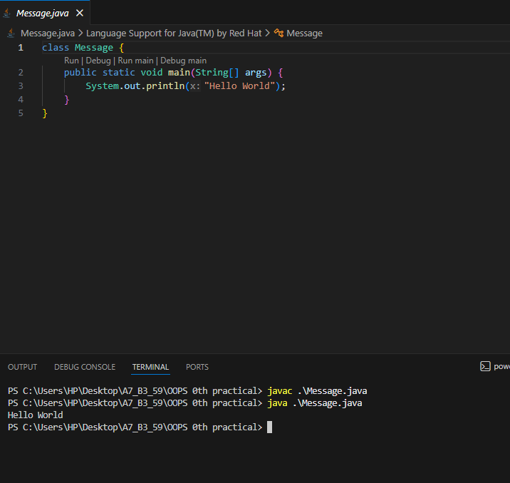
Output: Hello World
- Message1.java
- Program:

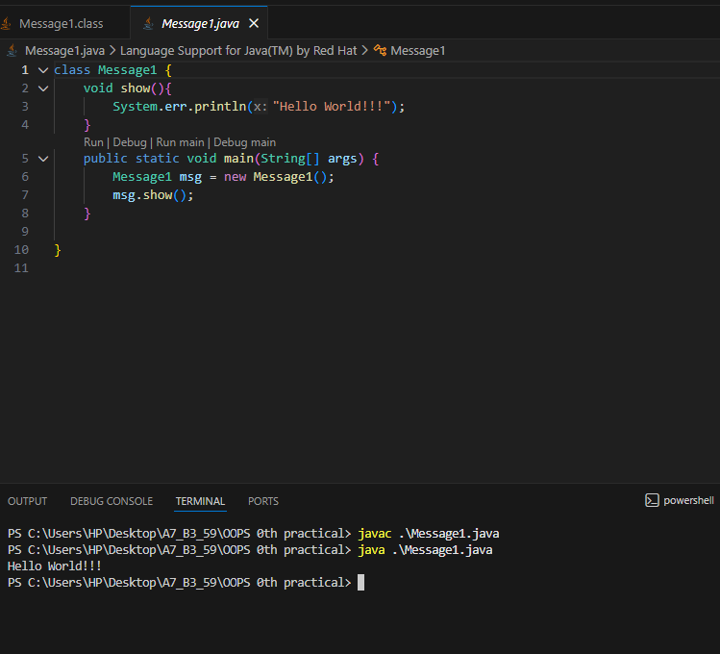
Output: Hello World!!!
- Mobile.java
Program:
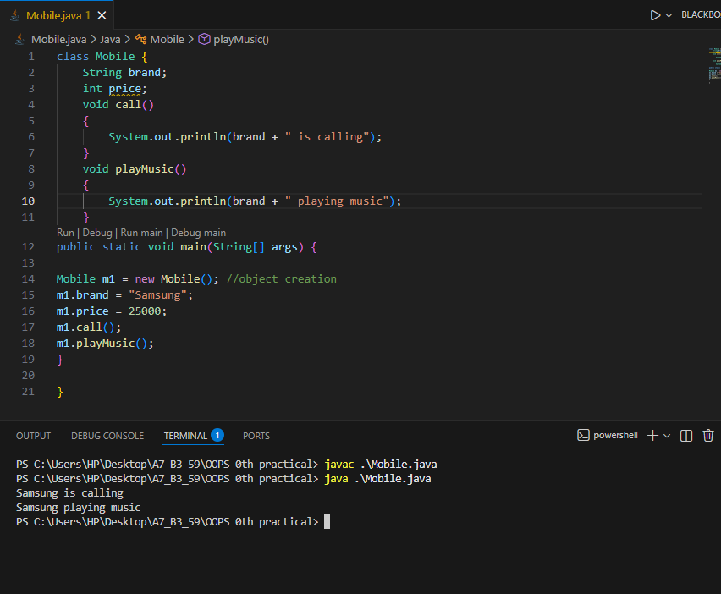
Output: Samsung is calling
Samsung playing music

